Decision tree

The program go in this steps

1] Read the data and copy it to original and copy

2] Implement edit in copy_data to remove the ‘?’

3] Then split data random take two parameter data and percent

4] Class tree node for build the tree

* It have two function to calculate the size of tree using recursive method

5] Function to calculate the information gain

* Take two parameter data and names of cols
* This function return the best node the have high information gain

6] Function build to build the tree

* It take one parameter root node and start build the based on conditions
* It return root node

7] Function predict output used to test case

* It take two parameter root node and each row from test data that comprise with
* It recursive until it found the answer

8] Function ptest to calculate the accuracy

* Take two parameter root and test data
* It return the accuracy

8] Then i start to have the output for first point

* Print the accuracy and tree size with ‘?’ mark

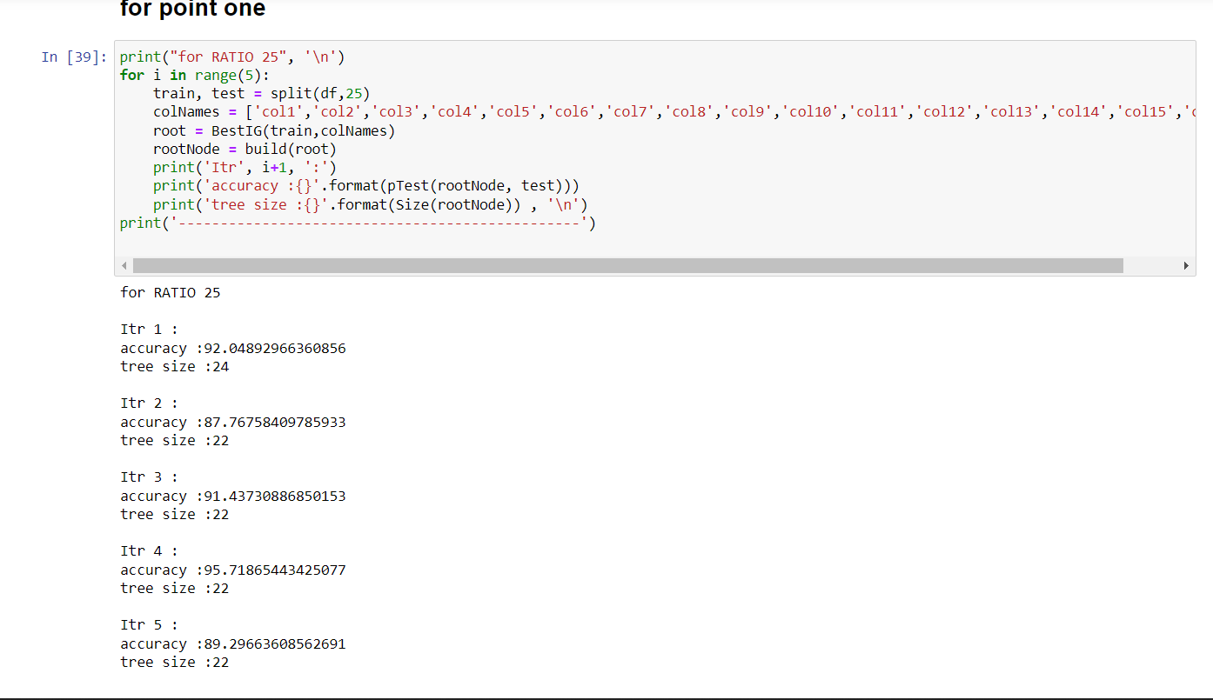

9] Print the accuracy and tree size and min max mean for both without ‘?’ for point two ration [30, 40, 50, 60, 70]

